Phase-3 Project Design
Date | 28-09-2026
Team ID | SWTID-2026-7624
Project name | Script – controlled ACL
Maximum marks | 4 marks

Here is the complete documentation for Phase 3: Project Design for your ServiceNow project, structured specifically for inclusion in your report or submission:

Phase 3: Project Design
- Data Architecture & Schema Design

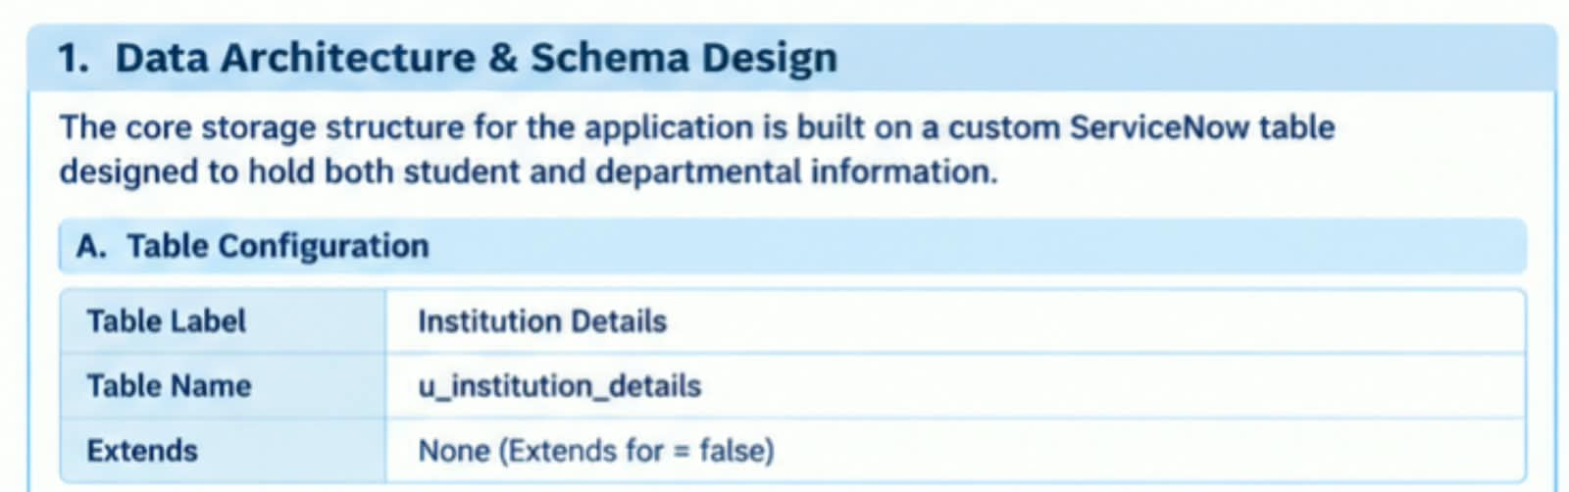

The core storage structure for the application is built on a custom ServiceNow table designed to hold both student and departmental information.

A. Table Configuration

Table Label: Institution Details

Table Name: u_institution_details

Extends: None (Extends for = false)

B. Field Dictionary Schema

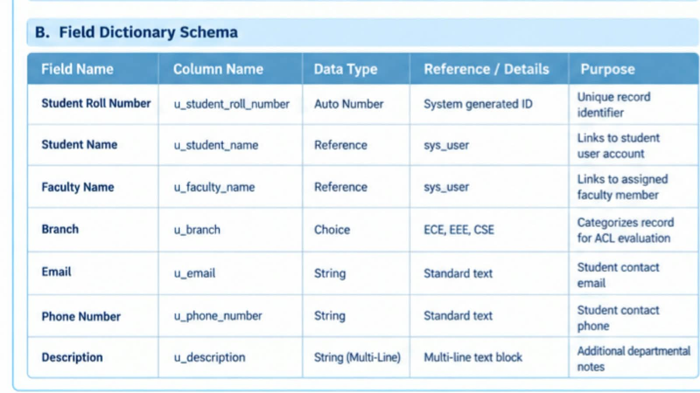
2. Security Architecture & Role Design

Access control is enforced using a combination of ServiceNow Custom Roles and Script-Controlled Access Control Lists (ACLs) to separate operational capabilities and isolate branch data.
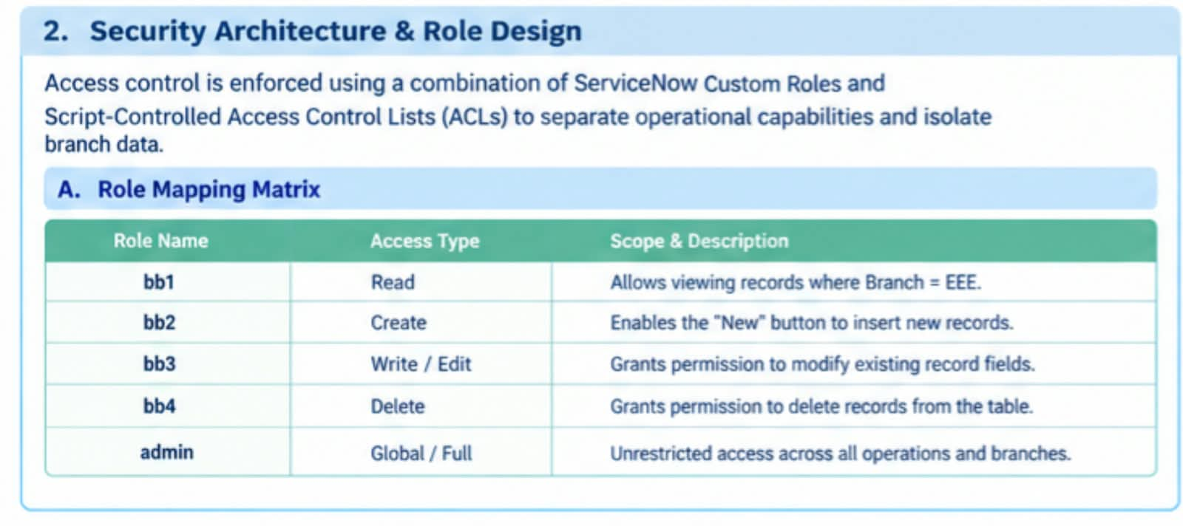

A. Role Mapping Matrix
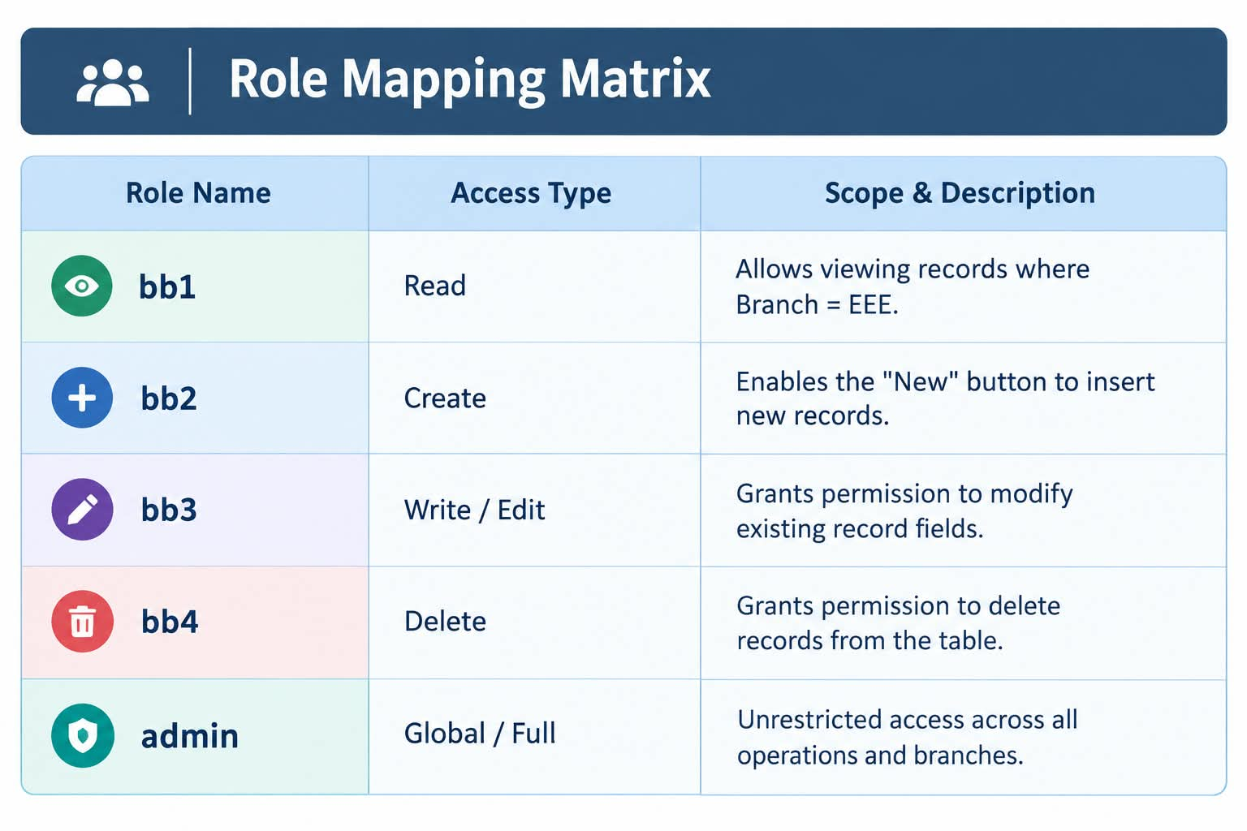

B. System Workflow Diagram
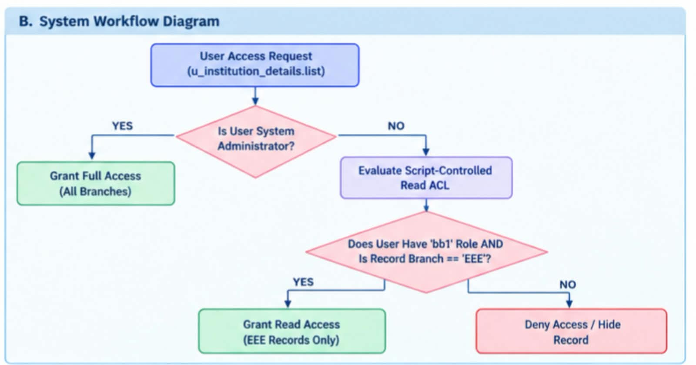

3. Script-Controlled ACL Logic Design
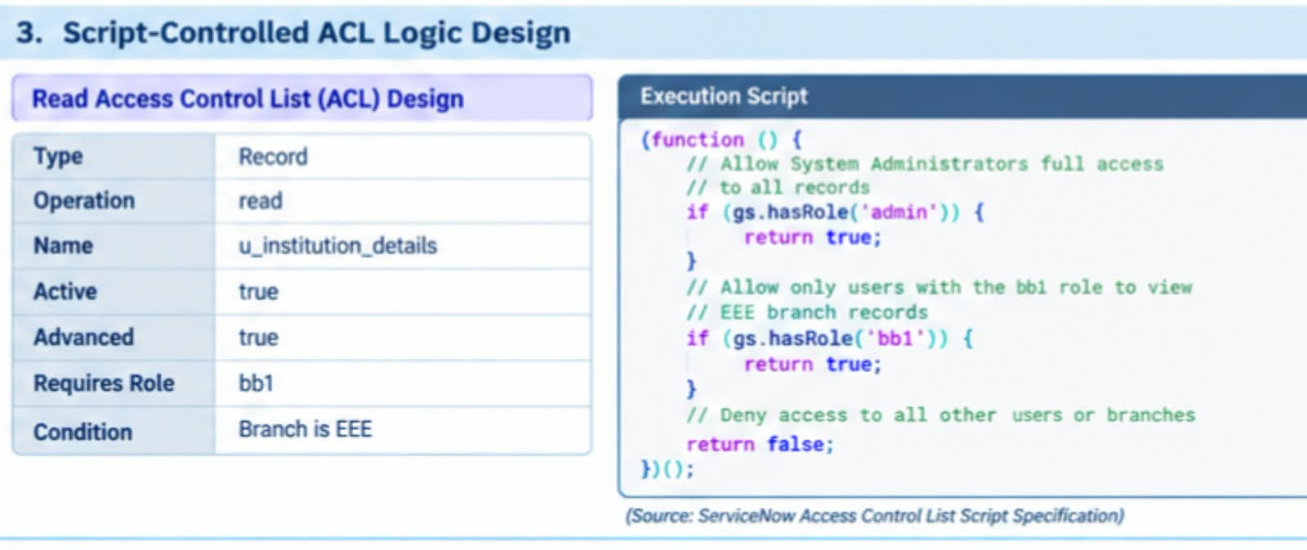
Read Access Control List (ACL) Design

Type: Record

Operation: read

Name: u_institution_details

Active: true

Advanced: true

Requires Role: bb1

Condition: Branch is EEE

Execution Script:

(function () { // Allow System Administrators full access to all records if (gs.hasRole('admin')) { return true; } // Allow only users with the bb1 role to view EEE branch records if (gs.hasRole('bb1')) { return true; } // Deny access to all other users or branches return false; })();
(Source: ServiceNow Access Control List Script Specification)

4. Operations & CRUD Design

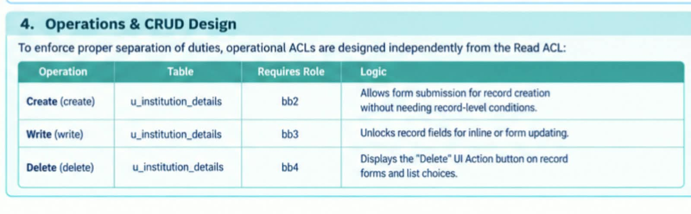
To enforce proper separation of duties, operational ACLs are designed independently from the Read ACL:

Create ACL (create):

Table: u_institution_details

Requires Role: bb2

Logic: Allows form submission for record creation without needing record-level conditions.

Write ACL (write):

Table: u_institution_details

Requires Role: bb3

Logic: Unlocks record fields for inline or form updating.

Delete ACL (delete):

Table: u_institution_details

Requires Role: bb4

Logic: Displays the "Delete" UI Action button on record forms and list choices.

